Chimera Games Engine Tutorials Tazi Mehdi

Tutorial 2 : Management Resources

Welcome to Chimera 2D Games Engine!
The Party will explain how to manage external resources such as images, music, fonts, effects….

- Using the content pipeline

It's easy!
1 - Begin by creating a new project Chimera
2 - Right click on content bitter you have a choice between adding a new element (if you want to

Create your own resource), or add an existing element if you want to import

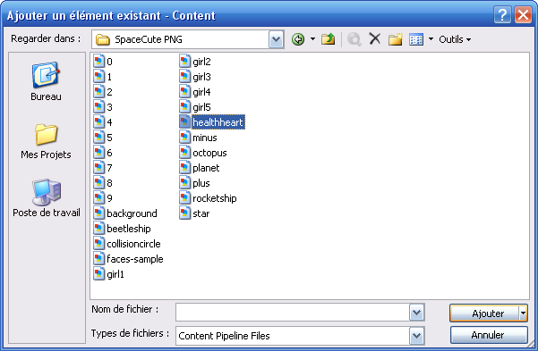

Assuming that it will import an image (2nd choice)
3-Assign a resource name (key).
That is the name that you will use later to load the resource

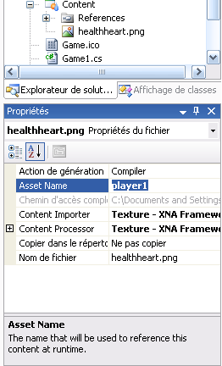

A Noted that it is entirely possible to load a resource fair with the code just by using

Chimera.Helpers.TextureManager (see next Tutorials)

